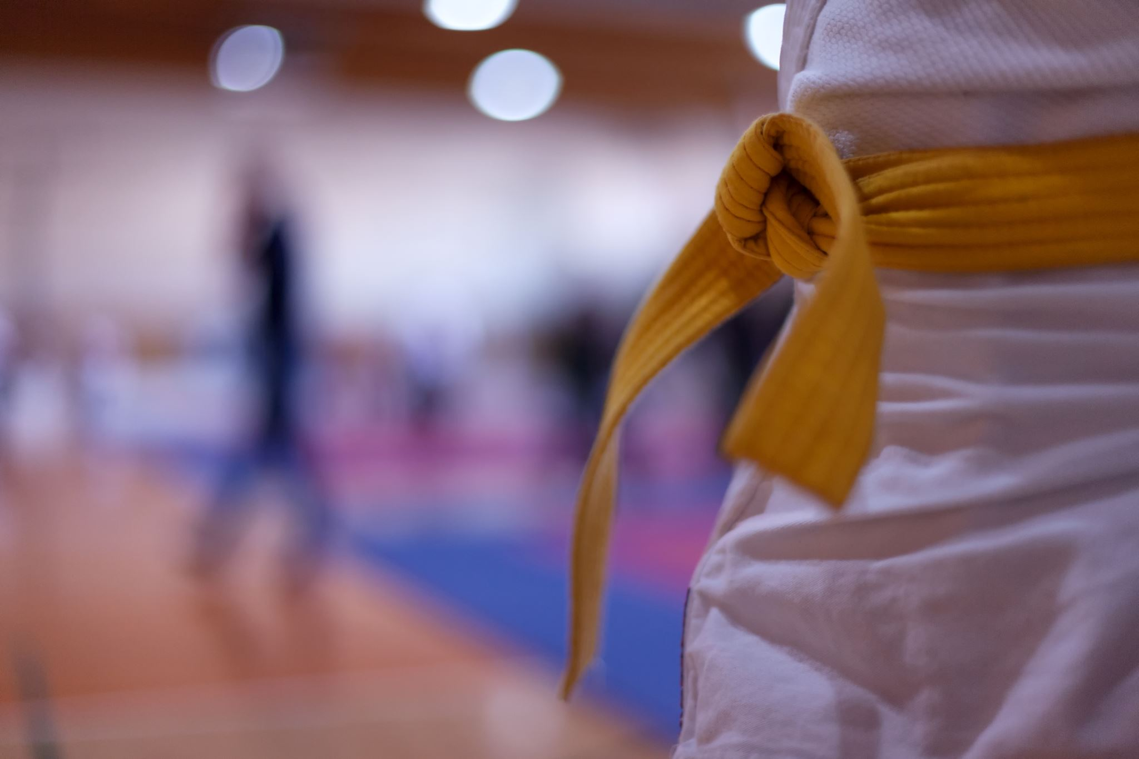
8/14/2024
Evaluation Report
Olympics
International Judo Club
Submitted By:
Elijah Shepherd

Submitted To:
Club Manager
Introduction
Background: You are working as a data analyst for an international judo club. The owner of the club is looking for new ways to leverage data for competition. One idea they have had is to use past competition data to estimate the threat of future opponents. They have provided you with a dataset of past Olympic data and want to know whether you can use information such as the height, weight, age, and national origin of a judo competitor to estimate the probability that they will earn a medal.
Purpose: Objectives of the analysis included:
- Assess the distributions of the values of the relevant variables to understand what values & corresponding data points may produce & have more representative conclusions.
- Determine how to calculate probabilities of winning Olympic medals along with other meaningful statistics for every distinct value across each of the relevant parameters.
- Calculate these probabilities & statistics for each parameter.
- Determine how & if it is possible to compile all these probabilities & statistics together so that unique combinations of every distinct value across the relevant parameters can be made.
- Determine how & if it is possible to calculate total probabilities for each of these combinations.
- Find ways to make this process simpler for users who may want to access & use these data.
- Illustrate some results & draw conclusions.
The findings & relevant analysis are to be provided to the judo club so that they can use the data to estimate the threat of future opponents.
The Data: The dataset used in this project pertained to historical statistics on the modern Olympic Games, from Athens 1896 to Rio 2016. Each row consists of an observation containing 15 variables including: a unique numerical identifier for each athlete, the athlete's name, the athlete's sex, the athlete's age (in years), the athlete's height (in centimeters), the athlete's weight (in kilograms), the team name that the athlete competed for, the national Olympic committee that the athlete competed for, the Olympic Game indicated by year & season, the year in which the Game occurred, the season in which the Game occurred, the host city of the Game, what sport was played, what event was played, & what medal was won if a medal was won.
The original dataset (defined as the "orig_df" variable) had 271,116 data points & had a size of 31.0+ megabytes. Four different columns had null values, but for the 'medal' column, the null values simply indicated that no medal was won in that specific data point (231,333 observations had "no" 'medal' value). These missing values were imputed with the value "unknown."
For the 'age,' 'height,' & 'weight' columns, there were 9,474, 60,171, & 62,875 missing values respectively. These values were ultimately replaced with an aggregate statistic such as the median or mean of the respective variable depending on how the values of that variable are distributed. More specifically, the mean is the more appropriate statistic when the distribution of the data is normal--evenly distributed--whereas the median is more appropriate when the distribution of the data is skewed. Skewness is the tendency for the values to be more popular at either the lower or upper two ends of the horizontal axis. The distributions of the age, height, & weight data are displayed in the figures below & help illustrate if they are skewed or not. Note that the vertical red line indicates the mean value of the respective parameter, & that the data used for these distributions does not include duplicate observations.
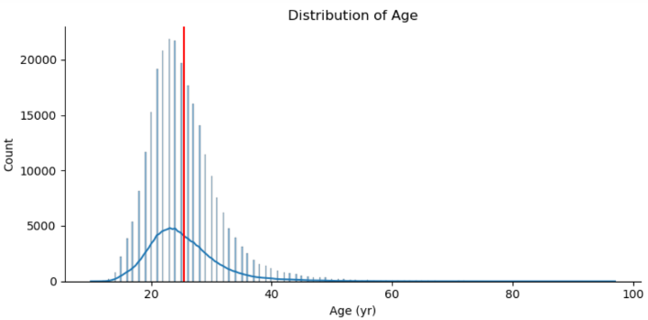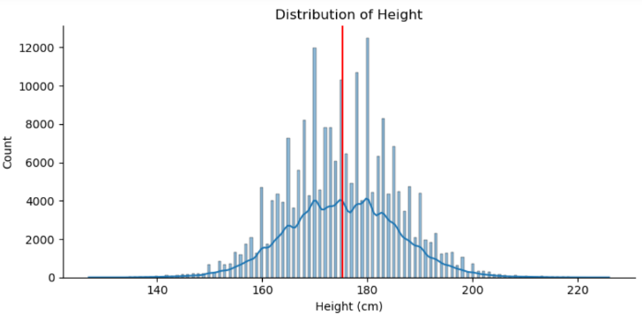
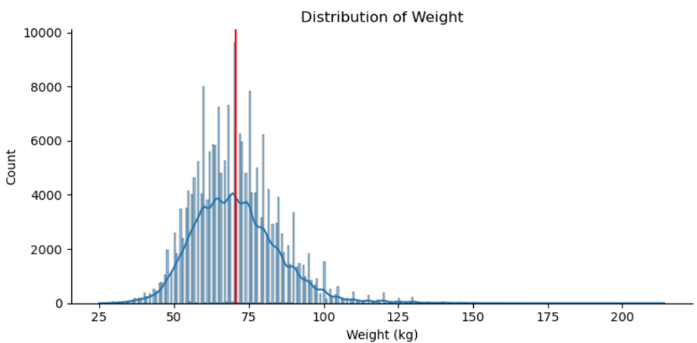
For age, the data is distributed towards the lower end of the horizontal axis, implying that the data is positively skewed. Also, the mean age is greater than the age of the peak of the age distribution. For height, the data has a fairly normal distribution & the mean is very close to the middle of the distribution. For weight, the data is distributed towards the lower end of the horizontal axis, implying that the data is positively skewed. The mean is very close to the weight of the peak of the weight distribution & maybe slightly greater than the peak value.
So, for the age & weight columns, the median should be used when imputing for their null values. For height, the mean should be used. Note that these imputations were not done until the data was reviewed for duplicate observations in the dataset because duplicate values would have an influence on these statistics.
The dataset was checked for instances of duplicate observations which revealed that there were 515 unique athletes who had complete duplicate entries in the original dataset, & they totaled 1,997 complete duplicates—observations that have the same value for every parameter. These duplicate observations were dropped, reducing the total number of data points in the dataset from 271,116 to 269,731. After duplicates were removed, the null values in the age, height, & weight columns were imputed with either the mean or median value of each column. The cleaned version of the dataset was defined as the variable "data."
Additionally, the column 'medal?' was created to indicate whether or not a medal was won for each observation.

Analysis
The Analysis: The analysis in the project that is relevant to this report is in the Analysis IV section, which begins about halfway into the python notebook. The main dataset (reference the variable "data") accounts for all sports, but judo is the only one of interest for the purposes of this report, which had 3,801 associated data points.
Firstly, it can be useful to get some contextual understanding of what judo involves as a sport. Per Google, judo "is an unarmed modern Japanese martial art, combat sport, Olympic sport (since 1964), and the most prominent form of jacket wrestling competed internationally. The objective of competitive judo is to throw an opponent, immobilize them with a pin, or force an opponent to submit with a joint lock or a choke." In the Olympics, judo is split by gender as well as by weight classes. Since 1992, there have been seven different weight classes for each gender. Additionally, a mixed team event was introduced at the Tokyo 2020 Olympic Games with three weight categories for each gender; however, this dataset does not include Olympic data beyond 2016 (Olympics.com).
When it comes to estimating the probability that an athlete may win a medal, it is straightforward enough to determine, though it may prove strenuous computationally. When multiple events occur, the probability of these combined events can be calculated by finding their product assuming that the events are independent. Independent events are events for which the outcome of one event does not affect the outcome of a second event. For example, if an athlete who is 25 years old competes in one Olympic event two separate times, the outcome of the second competition is independent from the outcome of the first competition.
This report aims to estimate the probability of a judo athlete winning an Olympic medal by using information such as their height, weight, age, & national origin. Using the cleaned version of the provided dataset (reference the variable "data"), the columns 'age,' 'height,' 'weight,' & 'noc' were used to help calculate these probabilities.
Regarding compiling all the total probabilities & other accompanying statistics, one option would be to collect the data of every possible combination of values of these four parameters & calculate how many medals have been won & not won by these associated athletes; however, given the size of this dataset, this may not be computationally possible using a standard computer system. Alternatively, a more viable option would be to calculate how often medals were won & lost for each unique value of age, height, weight, & noc separately, then combine these probabilities for each unique combination of these four parameters. Again, merging the results of these four parameters into one larger dataset may also be too computationally challenging, but in following the definition provided above, the total probability can be calculated across these four parameters even if they are kept separate & not all merged together.
Consider the following example. For an athlete who is 22 years old, 170 cm in height, 100 kg in weight, & from France ("FRA" 'noc'), the probability of such an athlete winning a medal can be calculated by finding the probability of each of the four scenarios occurring:
- The percentage in which a 22-year-old athlete has won a medal in past Olympic games,
- The percentage in which a 170-centimeter-tall athlete has won a medal,
- The percentage in which a 100-kilogram-weight athlete has won a medal, &
- The percentage in which an athlete from France has won a medal.
After determining these four probabilities, their product would yield the overall probability of such an athlete winning a medal. If the probabilities of the four points above are 20%, 10%, 8%, & 15% respectively, the probability of this hypothetical athlete winning a medal would be: 0.20 * 0.10 * 0.08 * 0.15 = 0.00024, or 0.024%.
This same process can be done in terms of winning any Olympic medal generally, but also for winning a specific medal (i.e. Gold, Silver, Bronze). Of course, other parameters can be incorporated into this analysis for judo athletes such as their 'sex' & the host 'city.' These probabilities could also be measured over time to see how they evolve.
As reflected in the first bullet point of the objectives listed previously in the report, it can be helpful to reassess the distributions of values across the relevant variables for this analysis. Doing so can help point to what parameters may have more representative data points & provide context for whatever results & conclusions are compiled. This was done both for the overall dataset & the data pertaining to judo.
After these distributions & their contextual findings were reviewed, the process of determining how to calculate the probabilities of interest followed. To start, the values of the parameters of interest were put into different combinations using the pandas.groupby() function to try & evaluate how many unique combinations there were across each parameter. This process of performing large-scale calculations & aggregations indicated that attempting to combine everything into a single dataset may be too computationally intensive to handle. For example, when performing this function on the four columns age, height, weight, & noc, the resulting dataset had over 52 million rows. If this dataset were used to calculate probabilities & other such statistics, it may take the system a significant amount of time if it can even complete it.
Across the five relevant parameters ('age,' 'height,' 'weight,' 'noc', & either of the two medal-related variables), there are multiple possibilities when aggregating the combinations of every unique value for each parameter. These possible combinations are listed below.
- 1 parameter: age & medal/medal?; height & medal/medal?; weight & medal/medal?; noc & medal/medal?
- 2 parameters: age, height, & medal/medal?; age, weight, & medal/medal?; age, noc, & medal/medal?; height, weight, & medal/medal?; height, noc, & medal/medal?; weight, noc, & medal/medal?
- 3 parameters: age, height, weight, & medal/medal?; age, height, noc, & medal/medal?; age, weight, noc, & medal/medal?; height, weight, noc, & medal/medal?
- 4 parameters: age, height, weight, noc, & medal/medal?
The more parameters that are involved will require more computational power & time to perform calculations.
Before calculating total probabilities for all of the relevant parameters, the medal-winning probabilities for each unique value of each parameter should be calculated. Probabilities were calculated for each value of age, height, weight, & noc across the two medal-related parameters 'medal' & 'medal?,' which indicate what medal was won & if a medal was won respectively. With these variables, statistics could be determined for each distinct medal & for all Olympic medals, which could then be used to calculate probabilities of winning a gold, silver, bronze, &/or any Olympic medal.
With these probabilities & statistics for each unique value of age, height, weight, & noc, the process of determining how to calculate total probabilities for combinations of values across these parameters could begin. As part of this process of evaluating the most appropriate method in which to calculate these probabilities, it was important to consider a few factors.
As discussed previously, given the depth of the relevant data, it may not be possible to completely determine statistics & probabilities for each unique combination of age, height, weight, & noc. Firstly, it was assessed whether or not this process was feasible. Then, other methods were explored such as trying to merge data together or avoiding huge aggregate calculations &/or merges of data. In other words, should the recently calculated data frames for age, height, weight, & noc (e.g. "judo_age_medal") be merged together into one dataset, or would it be more feasible to access certain values from each dataset separately & then calculate the total probability for whatever combination of parameters are of interest.
Additionally, depending on what process is utilized, it is possible that some of the unique values across the four relevant parameters are left out because they may not have any associated data. For example, given how many unique combinations there are across these parameters & that there are only about 3,800 data points pertaining to judo, it is likely inevitable that some combinations won't have any corresponding (non-zero) data points, & so they may not be included in any aggregate calculations or merges. Such data, however, is useful to have & therefore making sure it is included in any final dataset is an important point to keep in mind for constructing the code that follows.
To combine all the probabilities of each unique combination of every value across 'age,' 'height,' 'weight,' & 'noc,' a couple of different methodologies could be used.
- A complex, nested for loop could be used that loops through each value of 'age,' 'height,' 'weight,' 'noc,' & 'medal'/'medal?' to create every possible combination of these values. For each of these combinations, the number of observations in the dataset can be totaled, the number of medals won can be totaled, & the probabilities of winning a (or any) medal, gold medal, silver medal, & bronze medal can be calculated.
  - To access the probabilities of interest, it would require only one line of code such as something along the lines of:
dataframe[(dataframe['age'] == age) & (dataframe['height'] == height) & (dataframe['weight'] == weight) & (dataframe['noc'] == noc)]
- With the four datasets previously calculated containing the medal-winning probabilities & other statistics for each of the four parameters (e.g. "judo_age_medal"), they can be compiled/merged into a single data frame that has every unique combination of every value across each of the parameters. This would contain each of the medal-winning probabilities for each of the four parameters which can be used to calculate the total probability for each unique age-height-weight-noc combination.
  - To access the probabilities of interest, it would require only one line of code such as something along the lines of:
dataframe[(dataframe['age'] == age) & (dataframe['height'] == height) & (dataframe['weight'] == weight) & (dataframe['noc'] == noc)]
- Instead of compiling everything into a data frame with the millions of unique combinations of the values of these parameters, the four data frames previously calculated can be used separately to access the medal-winning probabilities for whatever values of age, height, weight, & national origin an athlete may have. These probabilities can then be used to calculate the total probability for an athlete to win a medal. Though this process is slightly more tedious, it does not require the computationally-intensive & time-consuming calculations as the former two methodologies would.
  - To access the probabilities of interest, it would require multiple lines of code likely involving something along the lines of:
age-dataframe[age-dataframe['age'] == age]
height-dataframe[height-dataframe['height'] == height]
weight-dataframe[weight-dataframe['weight'] == weight]
noc-dataframe[noc-dataframe['age'] == noc]
  - These four filters would return any associated data & their probabilities for that specific parameter, resulting in four groups of data. Then, the respective probabilities would have to be taken & be multiplied by one another, creating a product of four probabilities to yield one total probability for whatever subset of probabilities are desired (e.g. the column 'Medal Prob. (%)' for winning any medal, or the column 'Gold Prob. (%)' for winning a gold medal). An example of code of such a product is shown below.
(age-dataframe[age-dataframe['age'] == age]['Gold Prob. (%)']/100) *
(height-dataframe[height-dataframe['height'] == height]['Gold Prob. (%)']/100) *
(weight-dataframe[weight-dataframe['weight'] == weight]['Gold Prob. (%)']/100) *
(noc-dataframe[noc-dataframe['noc'] == noc]['Gold Prob. (%)']/100)
    - This value could be multiplied by 100 to get the total probability as a percentage.
Each of these three methodologies was trialed & the results are described subsequently.
Another alternative (or additional) strategy could involve taking the age, height, & weight parameters & splitting them into ranges of values. Rather than performing calculations for each unique value & combination across the parameters, the values of these three parameters could be grouped into ranges of values. Doing so would result in less total unique combinations across the four parameters & therefore less computational resources, making methods one & two potentially more viable; however, it would sacrifice precision because it wouldn't account for every possible judo athlete's unique age, height, weight, & national origin. Ultimately, these processes & the viability would probably depend on the sizes of these ranges of age, height, & weight. This alternative was explored later in the project & will be discussed more later.
Upon trialing these three methods, the first two quickly proved too computationally intensive, leaving the third as the most optimal. Before moving on, another alternative that was briefly explored involved recreating the four datasets containing statistics & probabilities previously calculated (e.g. "judo_age_medal"). Instead of performing these calculations for each parameter separately, they could be done with more than one parameter at a time, & then everything could be merged together after the fact. Unfortunately, this trial came to the same proverbial wall as methods one & two in that it proved too computationally intensive & time consuming.
As such, although the process is more laborious than either of the prior two methods, the third method was utilized to calculate total probabilities because it was significantly less computationally intensive & doable for the computer system that was being used.
An example of the process described in method three was constructed, the process of which suggested that a function could be created to help simplify the technique. The judo_athlete_probabilities function was created to take in certain values including an athlete's age, height, weight, & national origin which are used to filter the overall dataset to find various Olympic-related statistics of all judo athletes that relate to the listed parameters & their specified values. This filtered data is used to compile & calculate probabilities of such athletes regarding their winning of Olympic medals. With this function, the results can be obtained through one line of code.
Of course, it is possible that some combination of these parameters won't produce any results because there is no data to form such results from. In such cases, the most adjacent values for age, height, & weight can be used instead. This data would provide the most contextual information available for such athletes. As an example, there are no observations in the dataset in which an athlete has a weight of 45 kilograms (kg). The most adjacent value for which there is data is 46 kg, so this value could be used instead.
A drawback of the method constructed in the judo_athlete_probabilities function is that there are many values (& combinations of values) across the four parameters in which there is no data or there is very little data for which medal-winning probabilities can be calculated from. An alternative, as briefly mentioned earlier, could be to use & construct this data via the same method but instead of distinct values for the age, height, & weight parameters, ranges could be used for each of these parameters instead. For example, there are only a handful of judo athletes aged 40 years or older. Instead of applying the judo_athlete_probabilities function for each specific age above 40, the data associated with any judo athlete aged 40 years or more could be used instead, which would produce more results to construct probabilities with.
When it came to creating these ranges, it was more ideal for them to be smaller because the resulting probabilities would be more representative than such probabilities that are calculated using larger ranges of these parameters. Moreover, certain values may not even need to be put into a range if there are sufficiently enough observations. For example, the height of 175 centimeters (cm) had more than twice as many observations as any other height & it is near the middle point of the distribution of all the height values of judo athletes. Such a value with so many data points may not require it to be incorporated into a range with other neighboring values when calculating the medal-winning probabilities.
Ultimately, defining these intervals of age, height, &/or weight involves a compromise between representativeness & precision. Larger ranges may improve representativeness but would come at a cost to precision, & vice versa for smaller intervals.
When it came to 'noc' (an athlete's national origin), it is certainly possible to attempt to group the labels into different groups which could depend on geographic location or the associated number of data points. However, since this parameter is non-numerical, there is not much logical sense in divvying up the values as was done for age, height, & weight.
Recall that these probabilities were constructed so that a future athlete (or whatever interested user) may enter an age, height, weight, & national origin to evaluate the probabilities of those values of winning Olympic medals. These probabilities are based on historical data of previous Olympic athletes that relate to the specified values. When it comes to one's 'noc' value, it is less useful for an athlete to consider the probabilities of other 'noc' values than it is to consider the probabilities of other age, height, & weight values that may be adjacent to their own age, height, & weight. Of course, such athletes may want to know these probabilities for 'noc' values that are in or are near the same geographical region/country that they are competing for, but this information is not necessarily as decisive as that based on age, height, & weight. These three physical parameters are more prevalent in Olympic competition (especially sports & events that are more physically demanding) than a non-physical, logistical parameter as is an athlete's national origin; however, this does not mean that 'noc' cannot still have somewhat of an influence on an Olympic athlete's success.
With intervals of age, height, & weight for judo athletes defined, their construction of the medal-winning probabilities commenced. This process followed the same general steps as the previous construction of probabilities, the main difference being that they were calculated for each defined range of age, height, & weight rather than each unique value of these three parameters.
After these statistics & probabilities were calculated for each distinct range of age, height, and weight, a few functions needed to be made before creating the ultimate function which calculates the medal-winning probabilities given an athlete's age, height, weight, &/or noc. As with judo_athlete_probabilities, the final function should be as simple as possible for the user when it comes to entering their age, height, weight &/or noc values of interest. It would be unnecessarily cumbersome for them to have to find the appropriate age, height, &/or weight range as defined previously. As such, a couple of other functions were created to help accomplish this.
Given that the age/height/weight ranges were not all consistently defined, it was tricky to determine the corresponding range for a specific age/height/weight value. For example, given a unique age, the code needs to be able to determine what age range the value falls within. Since the ranges were not all consistently defined, this process of identifying the corresponding age range must consider all the possible scenarios in which the ranges were defined in order to check whether the age may associate with such ranges or not.
Two functions were made to determine the lower & upper limits of each age/height/weight range (respectively, reference the functions extract_lower_value & extract_upper_value). The limits then could be used to easily determine what ranges the specified value(s) of age/height/weight fall within.
Furthermore, in the quest of making the accessibility of the final function optimal, another function was created which takes in specified values of age, height, &/or weight & uses them to find the corresponding range of age/height/weight. Since the constructed statistics & probabilities were built using these ranges instead of unique values, it was necessary to make some function which converted such unique values into corresponding ranges as defined beforehand. This function is called find_AHW_ranges.
At this point, the final function, defined as judo_athlete_ranges_probabilities, was made. It follows the same processes as the judo_athlete_probabilities function & returns the same general results. With these two functions, potential users can simply input an age, height, weight, &/or 'noc' value of interest & retrieve corresponding probabilities & accompanying statistics regarding winning Olympic medals.
It is important to keep in mind that for the final probabilities (calculated using either of the functions judo_athlete_probabilities or judo_athlete_ranges_probabilities), they are calculated across two to four different parameters. Therefore, it is two-to-four times more likely that there is a zero probability somewhere which would result in the final probability being zero. Such cases, even if they follow the appropriate mathematical calculations, can sometimes be misleading. If one of the specified parameters has very little data, it is more likely that there weren't any instances in which a medal was won. As a result, it will produce a probability of zero, & no matter how high the probabilities may be for the other specified parameters, this zero will still cause the final probability to also be zero. Ultimately, these probabilities are statistics & reflective of what has happened in the past. They are not always indicative of what could or will happen in the future.
With the probability data constructed & made accessible in a simple manner, some illustrations were created to help visualize some findings. These illustrations were constructed for each of the four relevant parameters rather than involving multiple simultaneously. Moreover, illustrations were made for both processes utilized in the two main functions of interest. As such, there were seven general groups of illustrations (two each for age, height, & weight, one for noc). Some conclusions were drawn from each of the plots to help point out interesting and valuable findings.
Multiple python modules were used in the project including matplotlib, seaborn, plotly.express, regex, & others. Additional details & discussions are included throughout the project.
Results
Assess the Distributions of the Values of the Relevant Variables to Understand What Values & Corresponding Data Points May Produce & Have More Representative Conclusions
To start the analysis, it was valuable to review the distributions of the values of each of the relevant parameters, specifically age, height, weight, & noc. Doing so can help point to what parameters may have more representative data points & provide context for whatever results & conclusions are compiled. This was done both for the overall dataset & the data pertaining to judo.
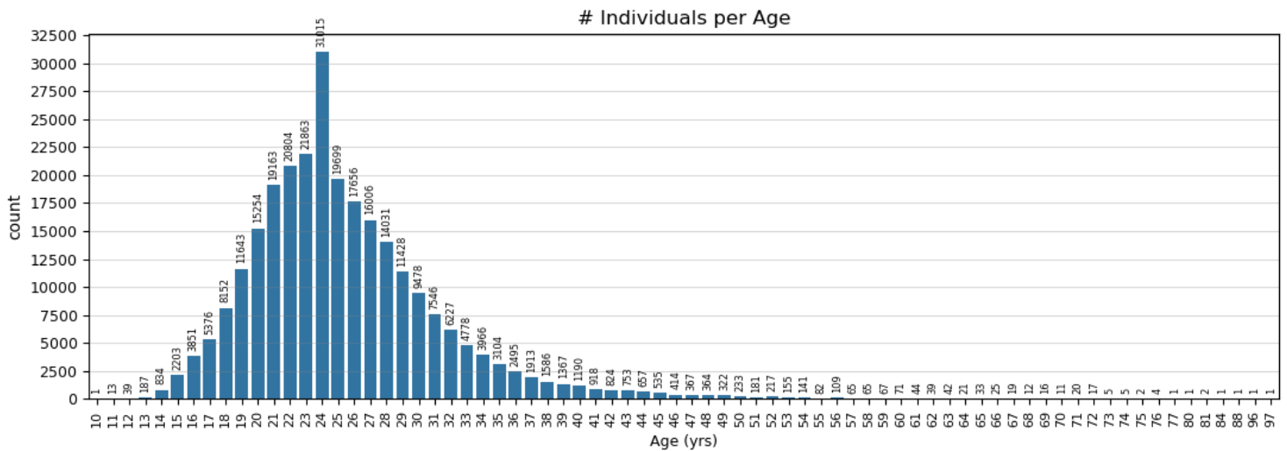
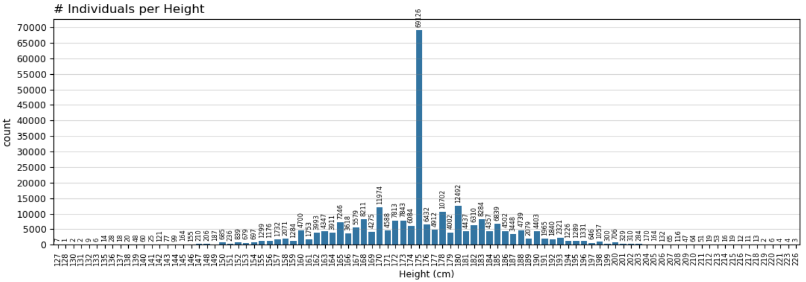
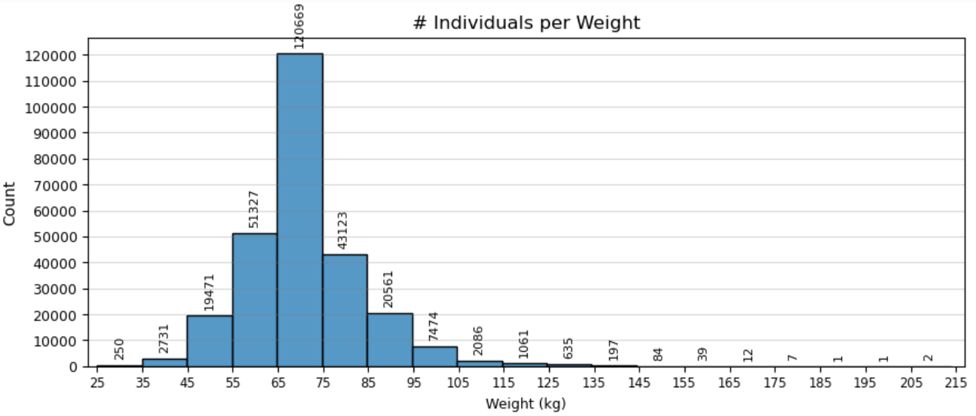
The three figures above pertain to the distributions of age, height, & weight respectively for the entire dataset (reference "data"). There are 74 unique 'age' values spanning from 10-97 years old. The most popular age is 24 years old. There are 95 unique 'height' values spanning 127-226 centimeters. The most popular height is 175 cm. There are 220 unique 'weight' values spanning from 25-214 kilograms. The most popular weight is 70 kg. The weight-plot above was made into a histogram with 19 bins because there are too many unique 'weight' values for the one plot to be reasonably legible. In terms of athletes' national origin, there are 230 unique 'noc' values (reference the "noc_counts" variable).
For the main dataset, age & weight are distributed towards lower values (positively skewed) whereas height is distributed fairly normally.
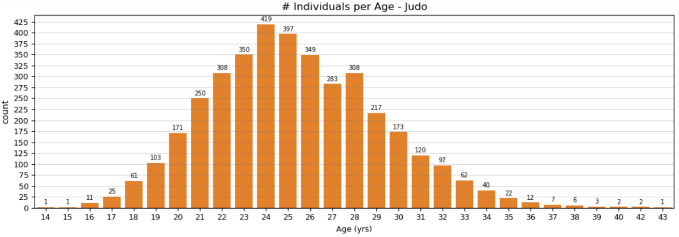
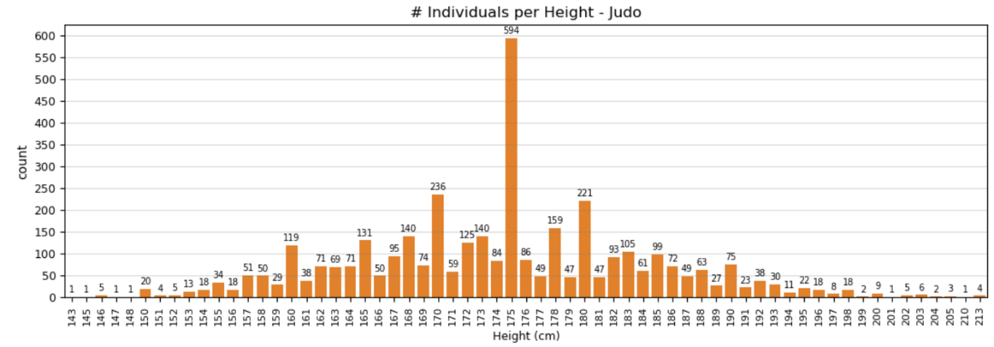
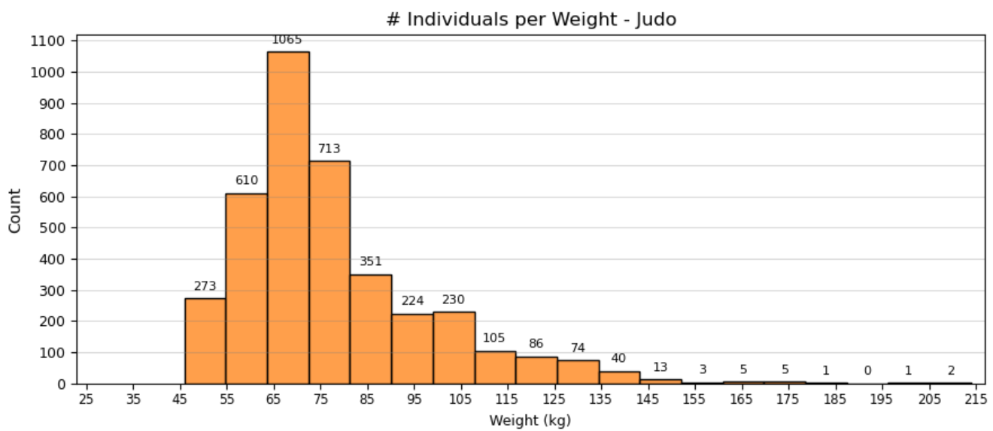
The three figures above pertain to the distributions of age, height, & weight respectively for the judo-related data (reference "judo_data"). There are 29 unique 'age' values spanning from 14-43 years old. The most popular age is 24 years old. There are 63 unique 'height' values spanning from 143-213 centimeters. The most popular height is 175 cm. There are 124 unique 'weight' values spanning from 46-214 kilograms. The most popular height is 70 kg. There are 180 unique 'noc's that have observations pertaining to judo (50 'noc's do not).
As was the case with the main dataset, height & weight are normally distributed & positively skewed respectively. On the other hand, age is less skewed for the judo data than it was for the entire dataset. This is mostly due to what values are present as age increases across these two sets of data. For the judo data, the max age is 43 whereas for the overall dataset, the max age is 97. Generally, the distributions of these parameters for the judo data are thinner than those of the main dataset.

Calculating Probabilities of Winning Olympic Medals Along with Other Meaningful Statistics for Every Distinct Value Across Each of the Relevant Parameters
This step involved the creation of four different datasets for each of the four relevant parameters. For each unique value of age/height/weight/noc, they included columns indicating how many gold, silver, & bronze medals were won, how many total medals were won & not won, the total number of observations (opportunities to win a medal), & the probabilities (as percentages) of winning a gold, silver, bronze, & any medal. These datasets were defined in the format "judo_{parameter}_medal" where {parameter} is one of either age, height, weight, or noc. An example of one of these datasets is shown below.
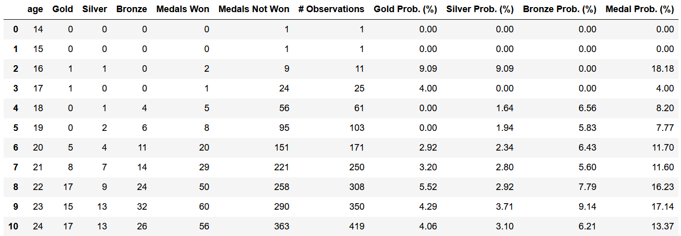
With these four datasets, it is possible to calculate total probabilities for specified values across the four parameters by multiplying each of the relevant probabilities together. If only one parameter is specified, this product is not necessary. Instead, one should simply filter the appropriate dataset for the parameter & value of interest to obtain the associated statistics & probabilities.

Determine How & if it is Possible to Compile All These Probabilities & Statistics Together so that Unique Combinations of Every Distinct Value Across the Relevant Parameters Can Be Made
As described in the Analysis section, three different methods were explored in attempting to create each combination of each unique value across the four parameters & then compiling their associated statistics & probabilities. Ultimately, the third method proved the most optimal, primarily because it was the only method that was doable.
To restate, the first method involved multiple nested for loops which went through every unique value of one parameter, concatenated them with every unique value of another parameter, & so on until all the possible combinations of values for age, height, weight, & noc were made. Then, for each of these combinations, the same general statistics & probabilities as shown above were to be calculated.
Even with condensing the parameters so that the loop only went through a few of them, the code still took an unreasonable amount of time to complete. In the fear that the code would not be able to complete should all the values of each parameter be used, this method was temporarily abandoned while the others were trialed.
The second method followed the same general method of attempting to compile everything into a single data frame. Instead of a giant for loop, each of the four previously calculated datasets (e.g. "judo_age_medal") would be merged into one single one which contained a row for each distinct combination of values across the four parameters. Firstly, a dataset was made (reference "judo_AHWN") which created every unique combination of values across the four parameters. This dataset, shown below, had over 52 million rows.
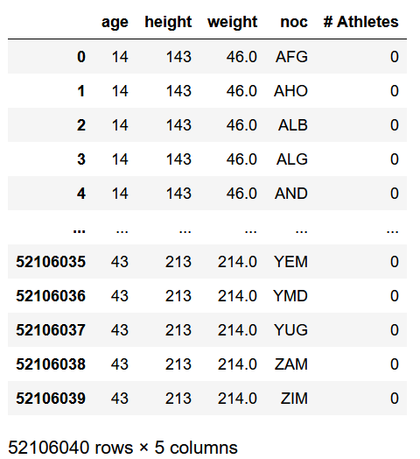
The next step merged this dataset with the statistics & probabilities of each unique age value, which was shown on the previous page. With some adjustments, the result of this merger is shown below. The last four columns are abbreviated by the type of medal & its probability & the associated parameter – "GP A" stands for Gold-Medal Probability (Age), "MP A" is for any medal.
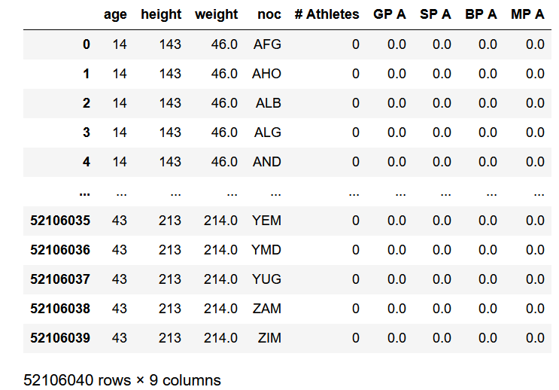
The following steps would involve merging this data with the statistics & probabilities of the height, weight, & noc datasets one at a time; however, in attempting to merge the height data ("judo_height_medal"), the code encountered a MemoryError. Essentially, the system was unable to allocate enough memory to complete this merger. As such, not only did it method two to bed, it suggested that attempting to merge all of these statistics & probabilities into a single dataset with over 52 million rows was not possible on the system which was being used.
Before advancing with method three, another alternative that was briefly explored involved recreating the four datasets containing statistics & probabilities (e.g. "judo_age_medal", etc.). Instead of performing these calculations for each parameter separately, they could be done with more than one parameter at a time (e.g. two or three), & then everything could be merged after the fact. Unfortunately, this experiment came to the same proverbial wall as methods one & two in that it proved too computationally intensive & time consuming.
Recall that the third method involved accessing each of the four relevant data frames by applying filters for whatever information is of interest, taking the medal-winning probabilities of interest, then multiplying the probabilities together to get a total probability. This process, though it may be more laborious than either of the prior methods, was significantly less computationally intensive & actually doable.

Determine How & if it is Possible to Calculate Total Probabilities for Each of These Combinations
An example of this third method was codified, which searched for judo athletes 22 years of age, 190 centimeters in height, & 125 kilograms in weight. Their national origin was not specified. The results are shown below. Of athletes in the judo-related data, there is no such athlete with this specific set of physical characteristics.
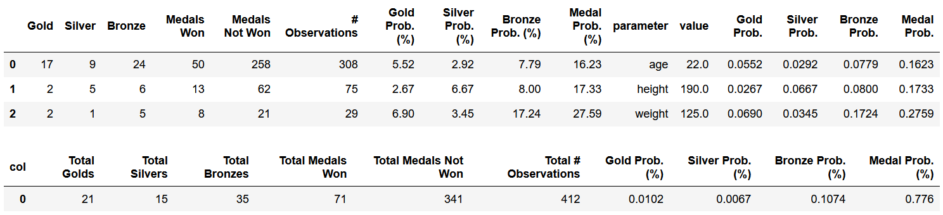
The first three data points are the statistics & probabilities for each of the unique parameters whose value was specified (age, height, & weight in this case). The final data point aggregates these values to get total values & probabilities. The probabilities were calculated by dividing the number of medals won by the total number of opportunities that were had to win that specific medal (or any medal in general). Recall that to calculate the probability of multiple events, the probability of each event needs to be multiplied together. Since three parameters were specified, the product contained three values for each of the four medal columns.
Note that the percentages of probabilities had to be converted to non-percentages before taking these products. Afterwards, they were converted back into percentages by multiplying them by 100. These probabilities above are easily verifiable. Also, the probability of winning any medal will always be greater than or equal to the largest probability of each of the three distinct medals (gold/silver/bronze) because the probabilities of these three medals summed together equal the probability of winning any medal; however, this is the case for each independent event (i.e. before the probabilities of each of the specified parameters are multiplied together) & not for the conjunction of all these events (after the probabilities are multiplied together).
For this hypothetical athlete aged 22 years with a height & weight of 190 centimeters & 125 kilograms respectively, their probabilities of winning Olympic medals are listed below. They also apply for such a judo athlete regardless of their national origin / the Olympic committee they compete under.
- Probability of winning any Olympic medal: ~ 0.776%
- Probability of winning a Gold Olympic medal: ~ 0.010%
- Probability of winning a Silver Olympic medal: ~ 0.007%
- Probability of winning a Bronze Olympic medal: ~ 0.107%

Find Ways to Make This Process Simpler for Users Who May Want to Access & Use These Data
In the example highlighted above, the code necessary was all included in a single cell, suggesting that the process of extracting these probabilities could be streamlined & made significantly simpler. A function, for example, could make these data points more readily available to any potential user. As such, the judo_athlete_probabilities function was created which takes in specified values of age, height, weight, &/or national origin & returns the corresponding probabilities & statistics for each specified parameter as well as the total probabilities (the same general results as included in the previous example).
With this function, a user can simply input any combination of specific values & get the corresponding medal-winning probabilities in a single line of code. Another example is displayed below using this function.
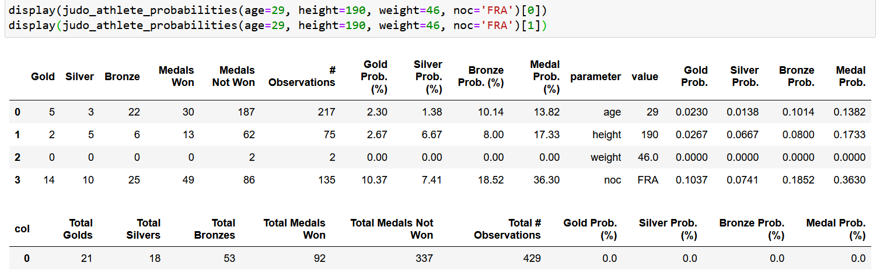

An Alternative Method in Calculating These Probabilities
As described in the Analysis section, one drawback in the judo_athlete_probabilities function is that there are many values (& combinations of values) across the four parameters in which there is no data or there is very little data for which medal-winning probabilities can be calculated from. An alternative could be to use & construct this data via the same method but instead of distinct values for the age, height, & weight parameters, ranges could be used for each of these parameters instead. For example, there are only a handful of judo athletes aged 40 years or older. Instead of applying the judo_athlete_probabilities function for each specific age above 40, the data associated with any judo athlete aged 40 years or more can be used instead, which would produce more results to construct probabilities with.
As such, the function judo_athlete_ranges_probabilities function was conceived which follows the same general steps as judo_athlete_probabilities but calculates the statistics for ranges of values across age, height, & weight instead of every unique value. First, however, these ranges had to be defined which was done in part by reviewing the distributions of age, height, & weight for the judo data.
Instead of 29 unique age values, this alternative method analyzed 22 unique age ranges. Instead of 63 unique height values, this alternative method analyzed 49 unique height ranges. Instead of 124 unique weight values, this alternative method analyzed 48 unique weight ranges. With intervals of age, height, & weight for judo athletes defined, calculations regarding statistics & probabilities of winning Olympic medals could then be constructed for each parameter. The associated datasets of three datasets are defined as: "judo_{parameter-abbreviation}range_medal" where {parameter-abbreviation} is the first letter of either age, height, or weight in capital form (e.g. "judo_Wrange_medal").
At this point, it is not yet possible to simply plug in some values for the four parameters of interest & get the associated results back. The user shouldn't have to look up the corresponding age, height, &/or weight range of the value of interest. As such, the three functions extract_lower_string, extract_upper_string, & find_AHW_ranges were created to help avoid this process. In combination, these three functions allow a potential user to simply input a distinct value for age, height, & weight, & the same general statistics & probabilities will be returned as was the case for the judo_athlete_probabilities function. These three new functions are explained in further depth in the Analysis section. An example of these three functions at work is shown below; the extract_lower_string & extract_upper_string are utilized within the find_AHW_ranges function & are not called directly.
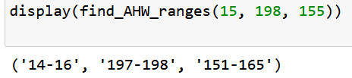
The three values within the find_AHW_ranges function specify the age, weight, & height of interest. In return, the function yielded the corresponding age, height, & weight ranges that would be used to calculate the associated medal-winning probabilities & statistics.
With these three functions, the function judo_athlete_ranges_probabilities was made to imitate the same calculations as the judo_athlete_probabilities function. An example of the results of both of these functions are shown below. The first three rows of statistics are the results from judo_athlete_probabilities whereas the last four rows are results from judo_athlete_ranges_probabilities.
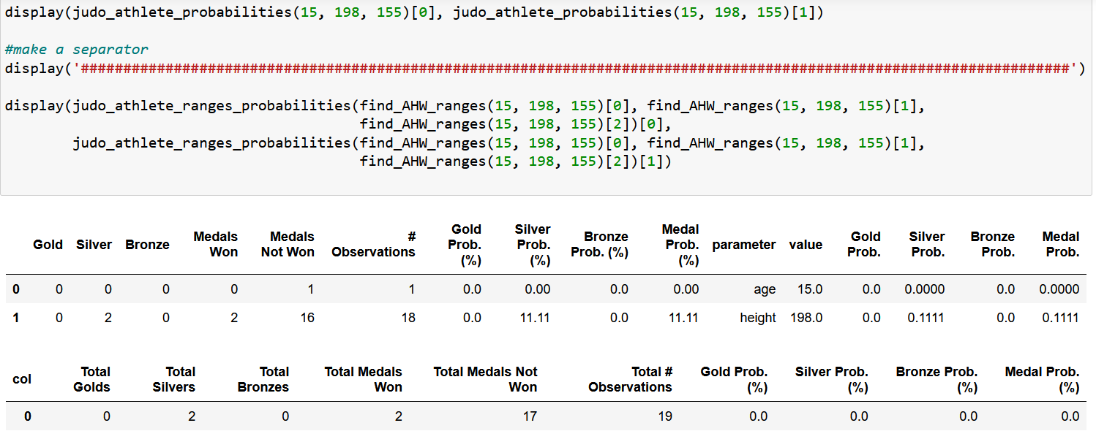
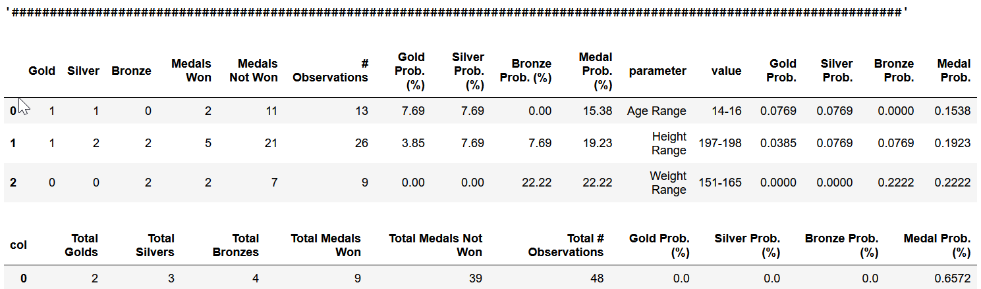
In the first set, no athlete (in judo) aged 15 years has won a medal, & so an athlete who is 15 years old & 198 cm in height has a total probability of zero in terms of winning Olympic medals. On the other hand, when the age of 15 is grouped together with the statistics of 14- & 16-year-old judo athletes, there is considerably more information & instances in which medals were won, & therefore non-zero probabilities of winning Olympic medals.
In using both of these two functions, their resulting sets of statistics illustrate how having the data incorporate some ranges of values across age, height, & weight can be beneficial for potential users.
Another example was built to provide an instance of how the noc parameter can influence the resulting statistics. This hypothetical athlete is 24 years old, 175 cm in height, 70 kg in weight, & competes under the Iraqi national Olympic committee ("IRQ"). In the data shown below, both functions were used. For the first set (the first eight rows), the noc parameter was not specified. For the second set (the last ten rows), the noc parameter was specified.
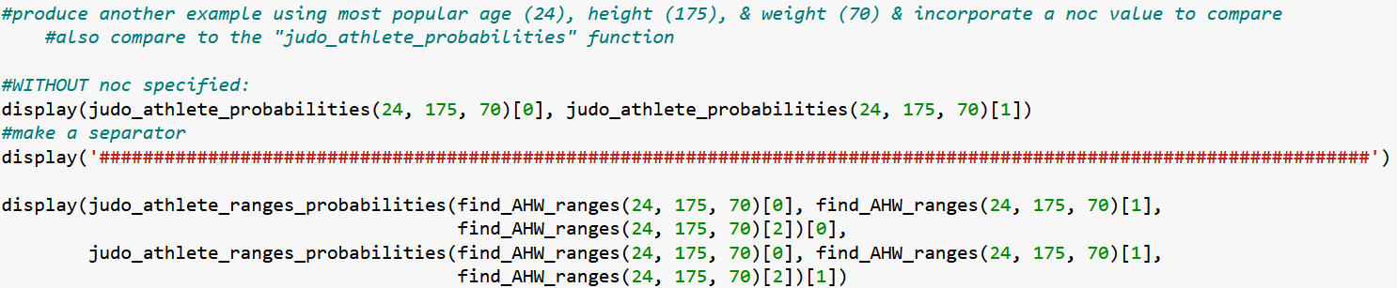
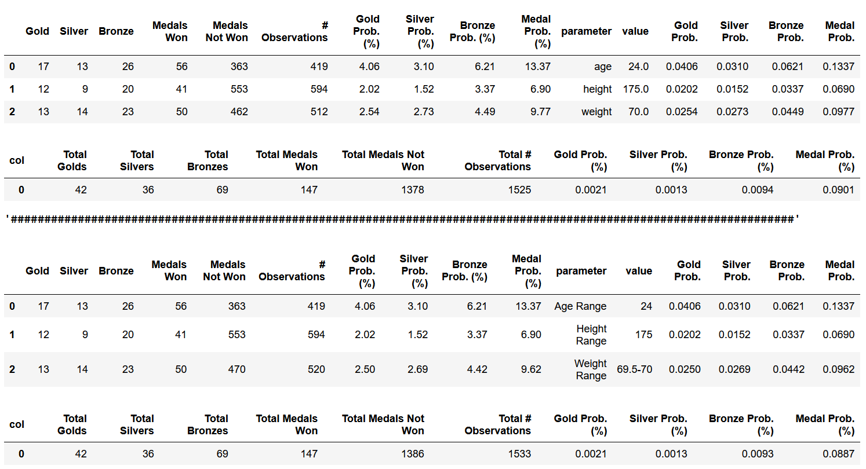
Now, with noc='IRQ'.
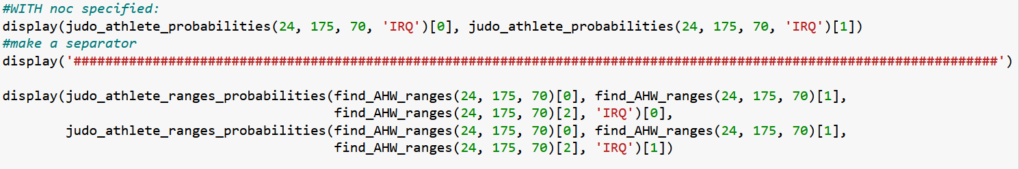
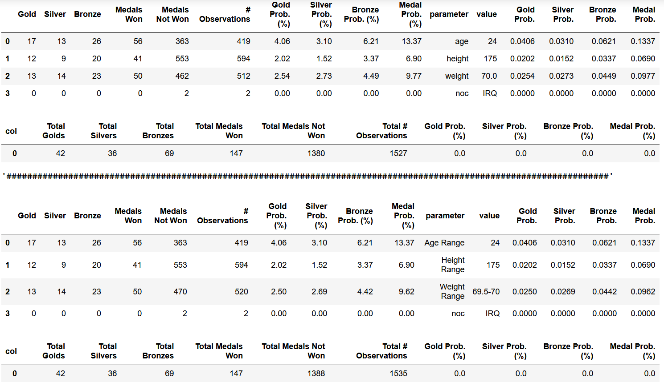
This example highlights a point that was highlighted previously where a parameter with very little data could produce misleading final probabilities. Clearly there is enough evidence to suggest that athletes whose physical attributes (age, height, weight) match these values have nonzero probabilities of winning Olympic medals. However, if the fourth parameter (noc) is specified to a value in which there are very little observations (or no won medals) for judo athletes, then the final probabilities will come out to be zero (e.g. Iraq has two data points & no medals for judo). Of course, this is statistically correct because no Iraqi athlete has ever won an Olympic medal in judo (from 1898-2016), but it does not mean that an Iraqi judo athlete with these three physical attributes cannot possibly win an Olympic medal. Given that there are only two such data points of Iraqi athletes competing in judo, there is not enough representative information to credibly state that Iraqi athletes cannot possibly win Olympic medals in judo. On the other hand, if there were a significantly representative number of data points for some noc value yet no medals were won, then it is more likely that this noc value is a relevant factor in such athletes' abilities to win Olympic medals.
This example simply emphasizes that probabilities are statistics & reflective of what has happened in the past. They are not always indicative of what could or will happen in the future.

Illustrate Some Results & Draw Conclusions
Several plots were made to visualize medal-winning probabilities across the four parameters. For age, there were few enough values to where every probability could be included in a single plot. On the other hand, height, weight, & noc had too many unique values to put every distinct medal-winning probability into a single plot for each parameter. Instead, multiple plots were made to include every unique value/range of values to ensure that the data was legible.
For age, height, & weight, two sets of plots were made for each parameter to account for both the probabilities calculated for each unique value (using judo_athlete_probabilities) & for the defined ranges (using judo_athlete_ranges_probabilities). For noc, since no ranges of values were defined, only one set of plots was built. Some findings are listed following each plot.

Age
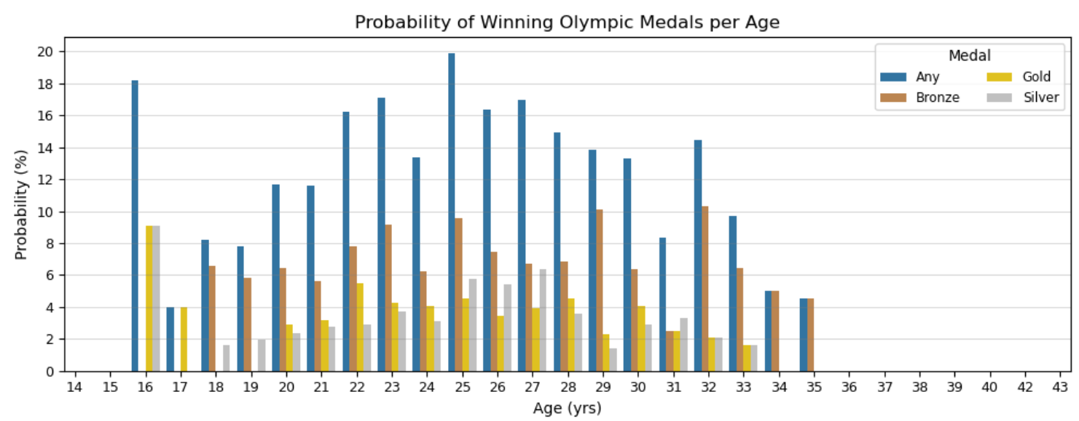
The plot above illustrates probabilities of winning Olympic medals per age among judo athletes. This data is not normalized based on the number of observations per age (e.g. judo athletes aged 16 won two medals in 11 attempts which is the second largest probability of winning any Olympic medal among judo athletes). No judo athlete aged less than 16 or above 35 years won any medals, so their probabilities of winning medals are zero. Some prominent findings are listed below:
- The five ages with the largest probabilities of winning bronze medals for judo athletes are 32, 29, 25, 23, & 22 years.
- The five ages with the largest probabilities of winning silver medals for judo athletes are 16, 27, 25, 26 & 23 years.
- The five ages with the largest probabilities of winning gold medals for judo athletes are 16, 22, 28, 25, & 23 years.
- The five ages with the largest probabilities of winning any Olympic medal for judo athletes are 25, 16, 23, 27, & 26 years.
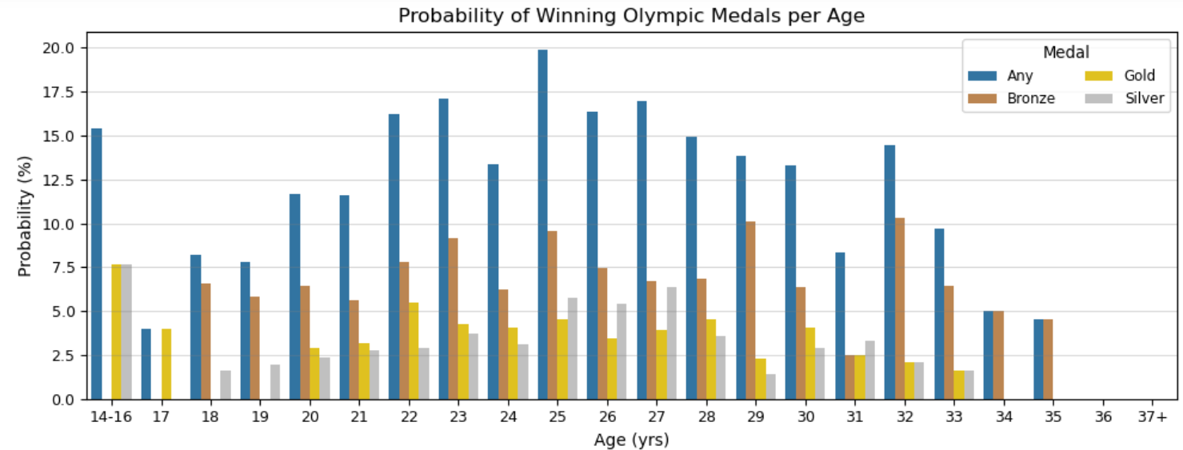
The plot above illustrates the probabilities of winning Olympic medals per age among judo athletes. This data is not normalized based on the number of observations per age. Instead of 29 unique age values, 22 age ranges were defined spanning 14-43 years. Some prominent findings are listed below:
- The five ages with the largest probabilities of winning bronze medals for judo athletes are 32, 29, 25, 23, & 22 years.
- The five ages with the largest probabilities of winning silver medals for judo athletes are 14-16, 27, 25, 26, & 23 years.
- The five ages with the largest probabilities of winning gold medals for judo athletes are 14-16, 22, 28, 25, & 23 years.
- The five ages with the largest probabilities of winning any Olympic medal for judo athletes are 25, 23, 27, 26, & 22 years.
Between these findings listed above & those of the previous plot (displaying data for each unique age), there are only six differences, one of which is major.

Height
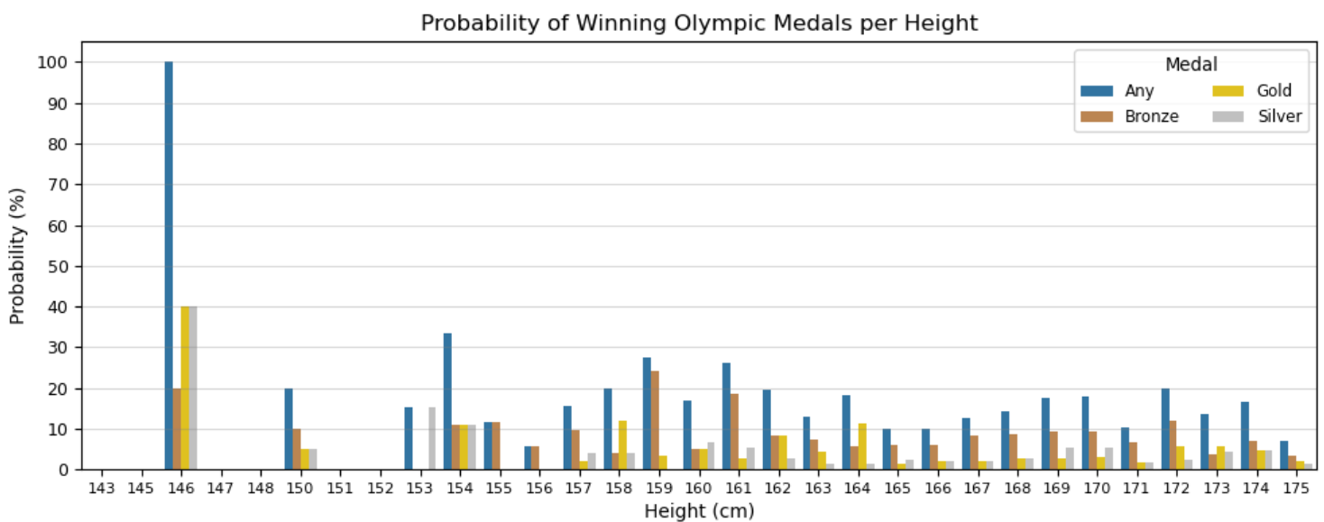
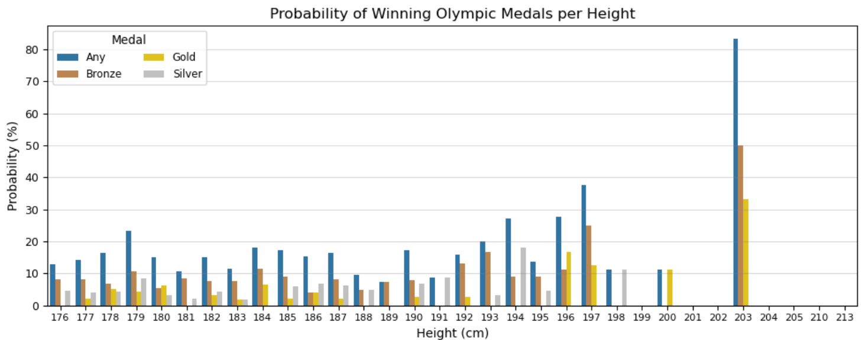
The plots above illustrate the probabilities of winning Olympic medals per height among judo athletes. Note that the ranges of the vertical axes across the two plots are not the same. This data is not normalized based on the number of observations per height. Heights with no data/bars indicate that that no medals were won of judo athletes with such heights, implying that those heights have a probability of zero of winning Olympic medals. Some prominent findings are listed below:
- The five heights with the largest probabilities of winning bronze medals for judo athletes are 203, 197, 159, 146, & 161 cm.
- The five heights with the largest probabilities of winning silver medals for judo athletes are 146, 194, 153, 154, & 198 cm.
- The five heights with the largest probabilities of winning gold medals for judo athletes are 146, 203, 196, 197, & 158 cm.
- The five heights with the largest probabilities of winning any Olympic medal for judo athletes are 146, 203, 197, 154, & 196 cm.
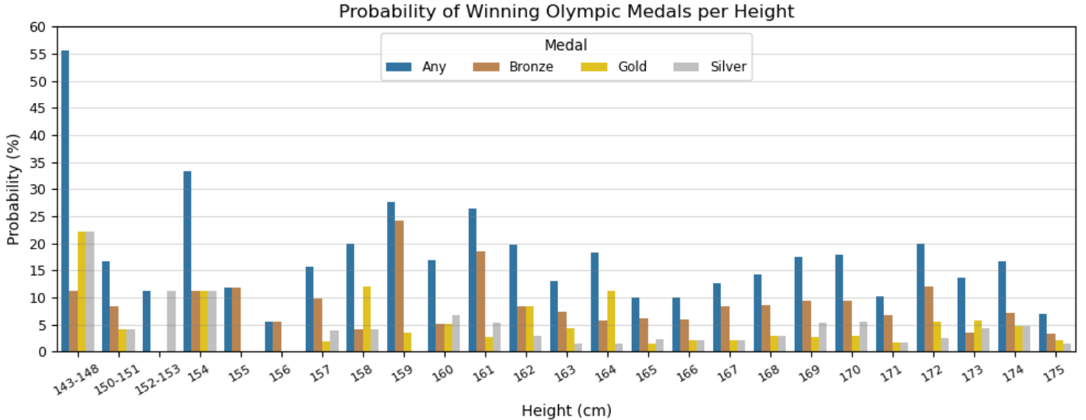
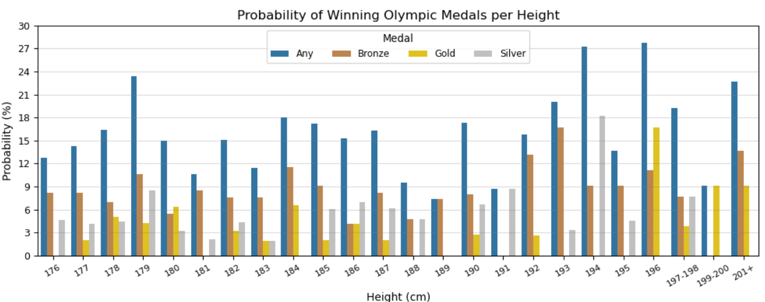
The plot above illustrates the probabilities of winning Olympic medals per age among judo athletes. Note that the ranges of the vertical axes across the two plots are not the same. This data is not normalized based on the number of observations per height which is important to keep in mind. Instead of 63 unique height values, 49 height ranges were defined spanning 143-213 centimeters. Some prominent findings are listed below:
- The five heights with the largest probabilities of winning bronze medals for judo athletes are 159, 161, 193, 201+, & 192 cm.
- The five heights with the largest probabilities of winning silver medals for judo athletes are 143-148, 194, 152-153, 154, & 191 cm.
- The five heights with the largest probabilities of winning gold medals for judo athletes are 143-148, 196, 158, 164, & 154 cm.
- The five heights with the largest probabilities of winning any Olympic medal for judo athletes are 143-148, 154, 196, 159, & 194 cm.
Between these findings listed above & those of the previous plot (displaying data for each unique height), there are multiple considerable differences.

Weight
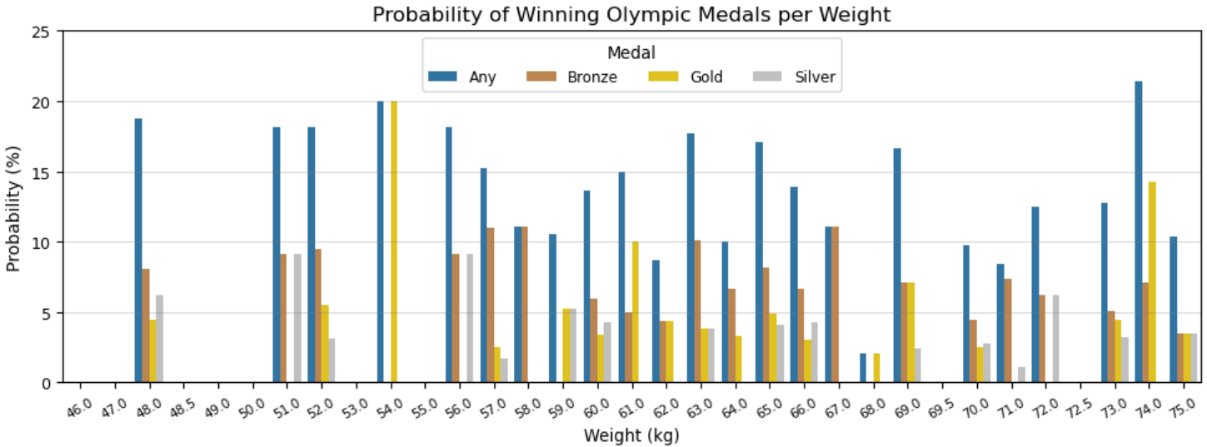
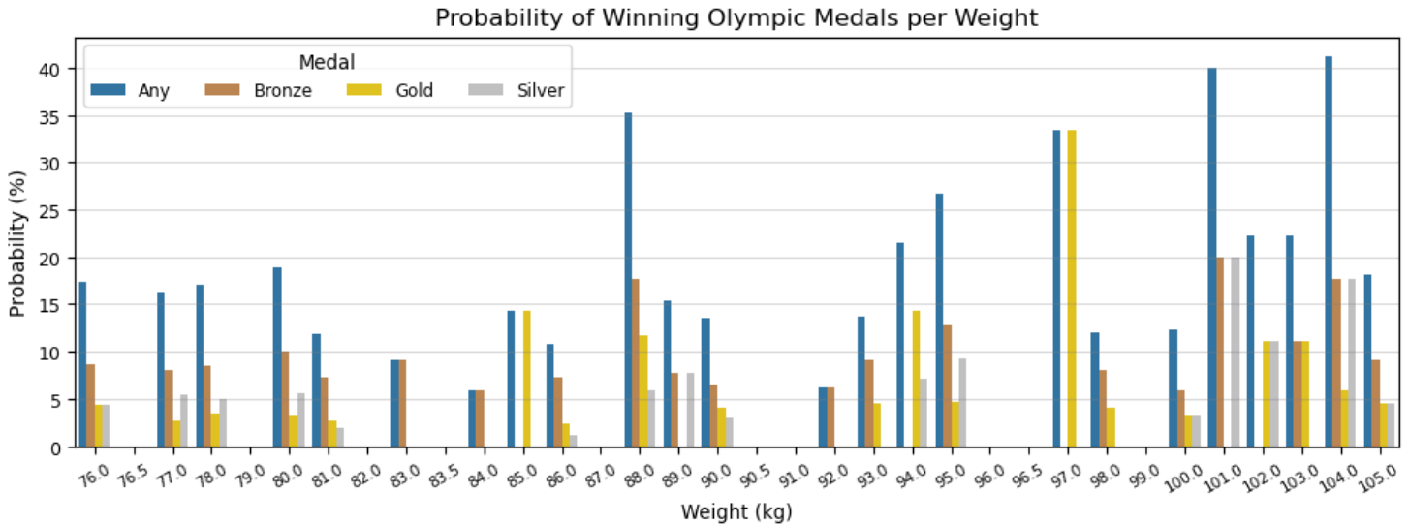
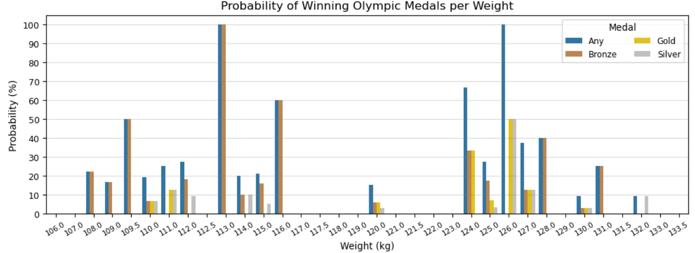
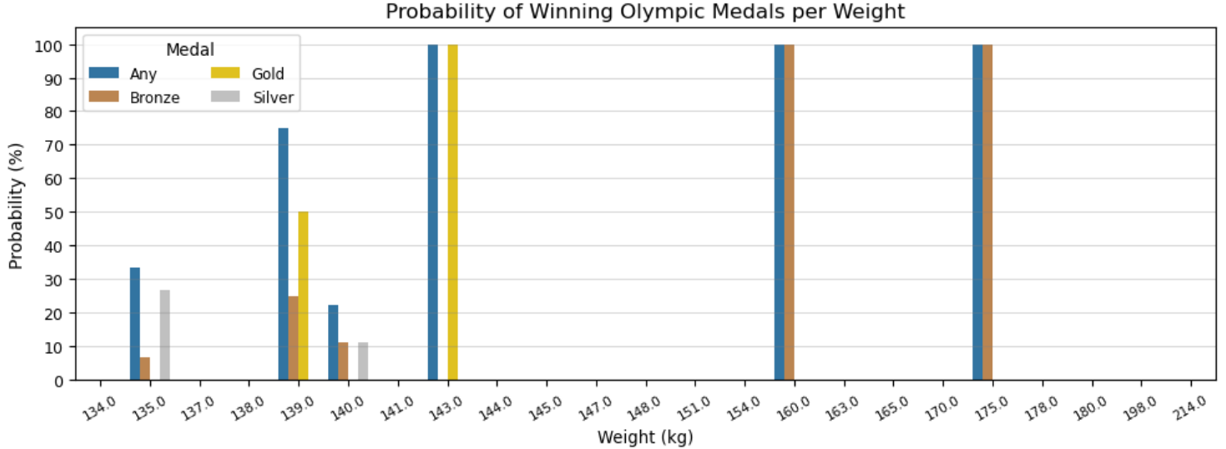
The plots above illustrate the probabilities of winning Olympic medals per weight among judo athletes. Note that the ranges of the vertical axes across the four plots are not the same. This data is not normalized based on the number of observations per weight. Weights with no data/bars indicate that that no medals were won of judo athletes with such weights, implying that those weights have a probability of zero of winning Olympic medals. Some prominent findings are listed below:
- The five weights with the largest probabilities of winning bronze medals for judo athletes are 160, 175, 113, 116, & 109.5 kg.
- The five weights with the largest probabilities of winning silver medals for judo athletes are 126, 135, 101, 104, & 127 kg.
- The five weights with the largest probabilities of winning gold medals for judo athletes are 143, 126, 139, 124, & 97 kg.
- The five weights with the largest probabilities of winning any Olympic medal for judo athletes are 113, 175, 126, 160, & 143 kg.
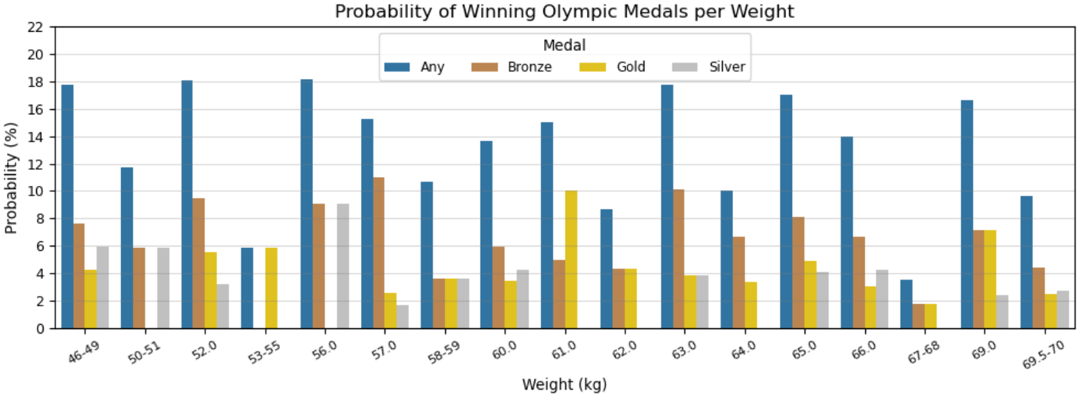
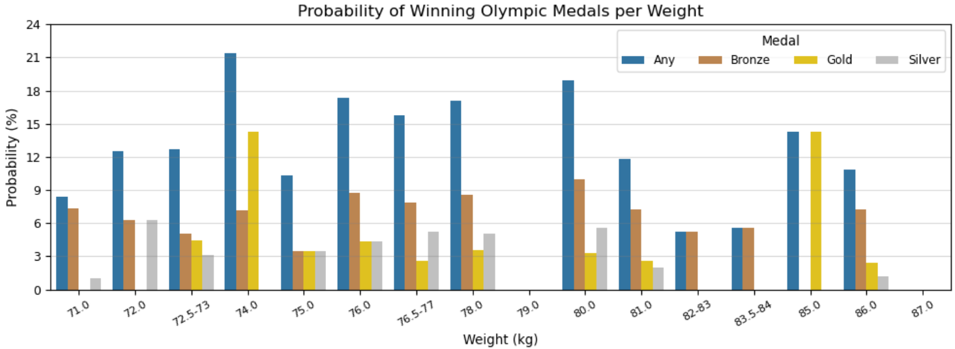
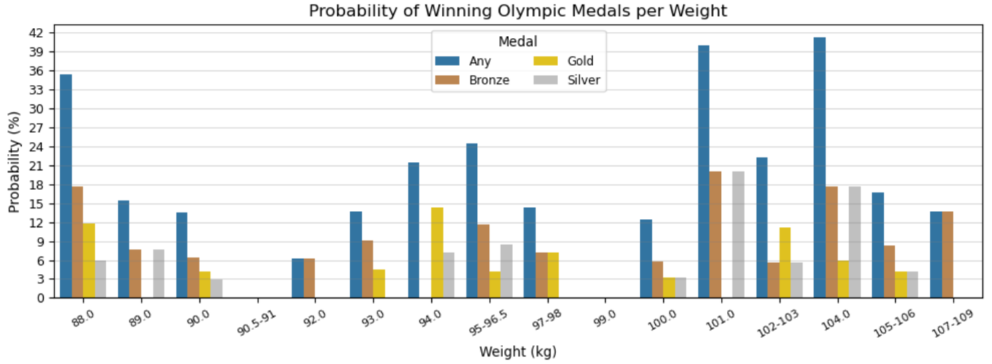
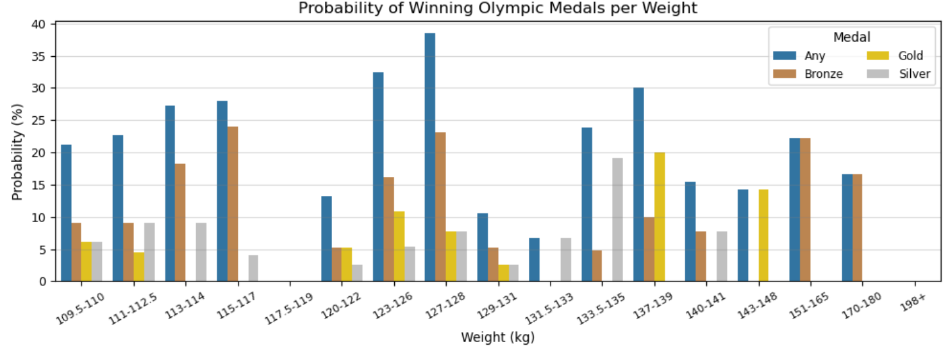
The plot above illustrates the probabilities of winning Olympic medals per weight among judo athletes. Note that the ranges of the vertical axes across the four plots are not the same. This data is not normalized based on the number of observations per weight which is important to keep in mind. Instead of 124 unique weight values, 48 weight ranges were defined spanning 46-214 kilograms. Some prominent findings are listed below:
- The five weights with the largest probabilities of winning bronze medals for judo athletes are 115-117, 127-128, 151-165, 101, & 113-114 kg.
- The five weights with the largest probabilities of winning silver medals for judo athletes are 101, 133.5-135, 104, 56, & 113-114 kg.
- The five weights with the largest probabilities of winning gold medals for judo athletes are 137-139, 85, 143-148, 94, & 74 kg.
- The five weights with the largest probabilities of winning any Olympic medal for judo athletes are 104, 101, 127-128, 88, & 123-126 kg.
Between these findings listed above & those of the previous plot (displaying data for each unique weight), there are multiple considerable differences.

NOC
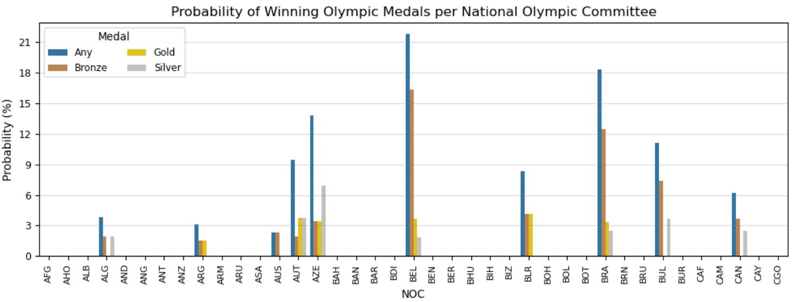
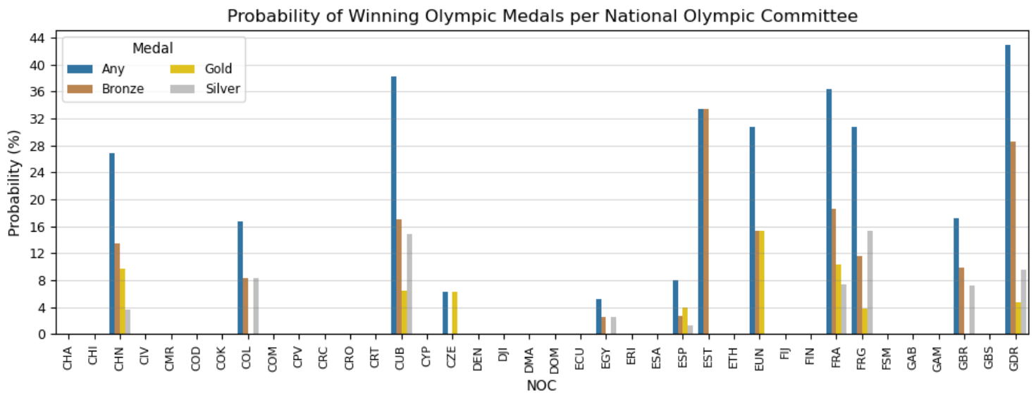
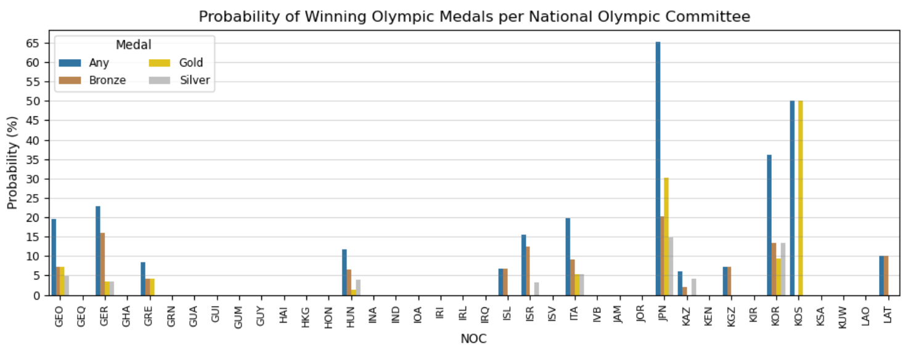
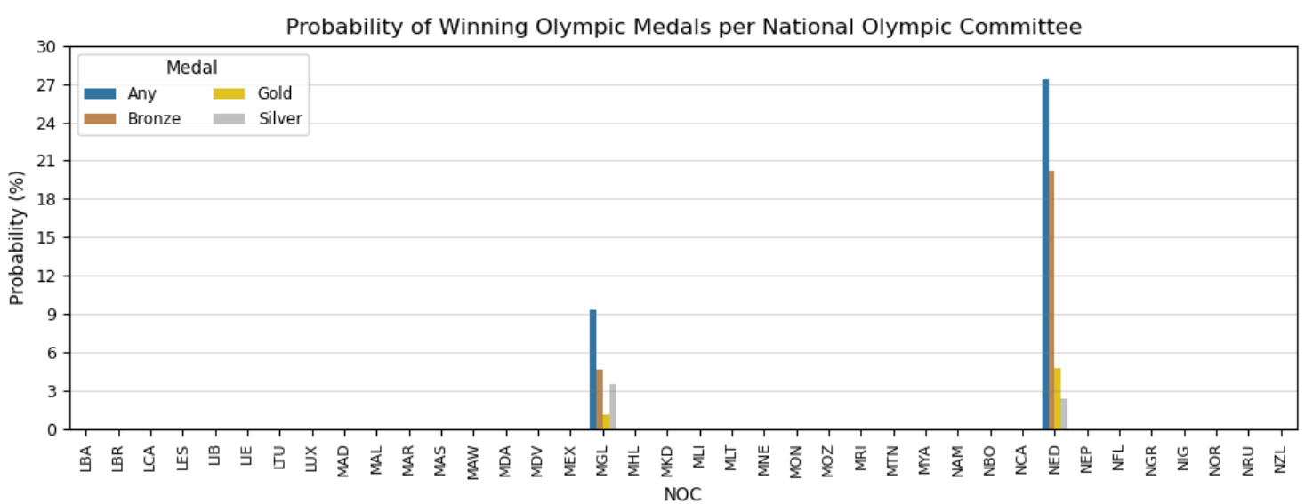
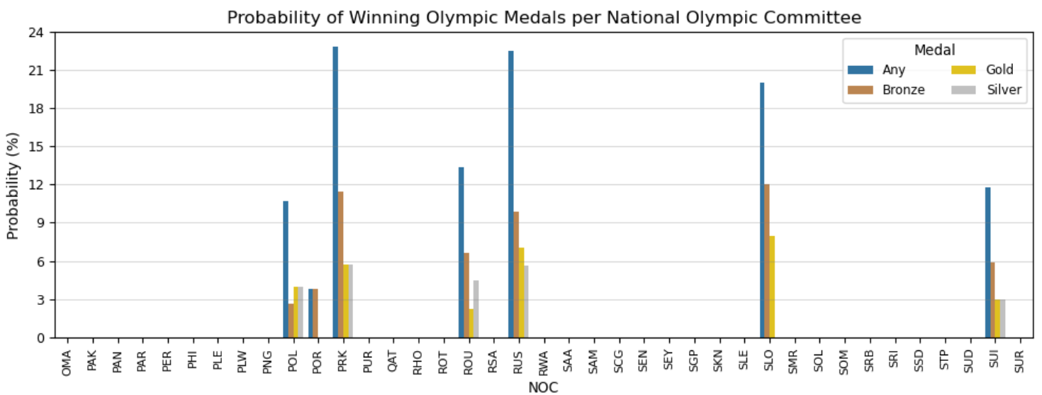
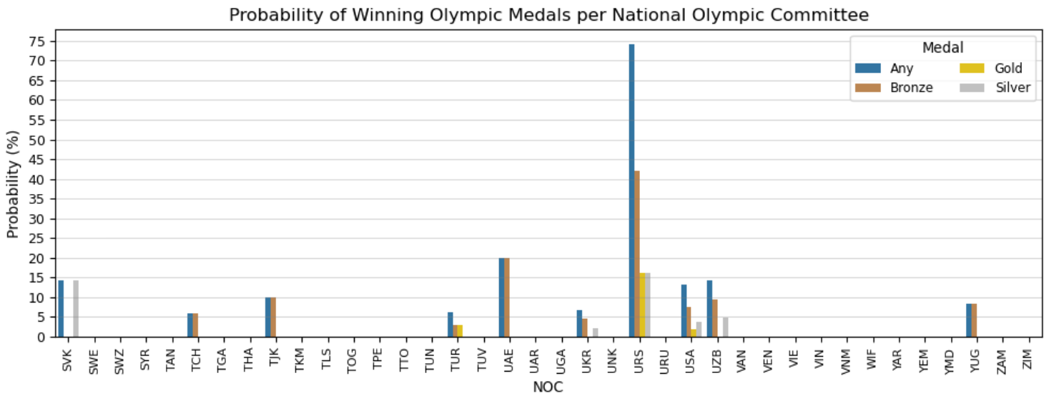
The plots above illustrate the probabilities of winning Olympic medals per national Olympic committee among judo athletes. Note that the ranges of the vertical axes across the six plots are not the same. This data is not normalized based on the number of observations per noc. National Olympic Committees with no data/bars indicate that that no medals were won by judo athletes that competed under that noc, implying that those Olympic committees have a probability of zero of winning Olympic medals. Some prominent findings are listed below:
- The five committees with the largest probabilities of winning bronze medals for judo athletes are URS (the Union of Soviet Socialist Republics, a.k.a. the Soviet Union), EST (Estonia), GDR (the Germany Democratic Republic, a.k.a. East Germany), NED (the Netherlands), & JPN (Japan).
- The five nocs with the largest probabilities of winning silver medals for judo athletes are URS (the Soviet Union), FRG (the Federal Republic of Germany, a.k.a. West Germany), CUB (Cuba), JPN (Japan), & SVK (Slovakia).
- The five committees with the largest probabilities of winning gold medals for judo athletes are KOS (Kosovo), JPN (Japan), URS (the Soviet Union), EUN (the Unified Team -- the name used for the sports team of the former Soviet Union (except the Baltic states) at the 1992 Winter & Summer Olympic Games. The IOC country code was EUN, after the French name, Équipe unifiée.), & FRA (France).
- The five committees with the largest probabilities of winning any Olympic medal for judo athletes are URS (the Soviet Union), JPN (Japan), KOS (Kosovo), GDR (East Germany), & CUB (Cuba).
There is certainly a lot that can be unpacked here across the various noc's that are listed above. Some still exist & compete in the Olympics currently, but many do not including URS, GDR, FRG, & EUN. Of course, external research could add more context to this information, such as the suspicion that East Germany's Olympic success may have been in relation to doping (taking steroids to enhance a competitor's performance), but this process extends beyond what is involved in the primary objectives of this section.
Note that the 'noc' variable represents the national Olympic committee in which an athlete competed for, so it doesn't necessarily imply that it is that athlete's national origin.

Conclusions
Recall the goals of the project. The primary objectives included:
- Assess the distributions of the values of the relevant variables to understand what values & corresponding data points may produce & have more representative conclusions.
- Determine how to calculate probabilities of winning Olympic medals along with other meaningful statistics for every distinct value across each of the relevant parameters.
- Calculate these probabilities & statistics for each parameter.
- Determine how & if it is possible to compile all these probabilities & statistics together so that unique combinations of every distinct value across the relevant parameters can be made.
- Determine how & if it is possible to calculate total probabilities for each of these combinations.
- Find ways to make this process simpler for users who may want to access & use these data.
- Illustrate some results & draw conclusions.
The analysis of the project associated with this report constructed probabilities that a judo competitor will earn an Olympic medal based on their height, weight, age, & national origin. Of the approximately 270,000 data points in the main dataset, about 3,800 of them pertain to judo-related events.
A simple understanding of probability is all that is necessary to compute such calculations based on between one & four different parameters, which in this case include the variables 'age,' 'height,' 'weight,' & 'noc' ('noc' is the best indicator in the dataset of an athlete's national origin). When multiple events occur, the probability of these combined events can be calculated by finding their product assuming that the events are independent. Independent events are events for which the outcome of one event does not affect the outcome of a second event. For example, if an athlete who is 25 years old competes in one Olympic event on two separate occasions, the outcome of the second competition is independent from the outcome of the first competition.
For example, an athlete who is 22 years old, 170 cm in height, 100 kg in weight, & from France ("FRA" noc), the probability of such an athlete winning a medal can be calculated by finding the probability of each of the four scenarios occurring:
- The percentage in which a 22-year-old athlete has won a medal,
- The percentage in which a 170-centimeter-tall athlete has won a medal,
- The percentage in which a 100-kilogram-weight athlete has won a medal, &
- The percentage in which an athlete from France has won a medal.
After determining these four probabilities, their product would yield the overall probability of such an athlete winning a medal. If the probability of the four points above are 20%, 10%, 8%, & 15% respectively, the probability of this hypothetical athlete winning a medal would be: 0.2 * 0.1 * 0.08 * 0.15 = 0.00024 or 0.024%.
This same process can be done in terms of winning a medal generally, but also for winning a specific medal (i.e. Gold, Silver, Bronze). Of course, other parameters can be incorporated into this analysis for judo athletes such as their 'sex' & the host 'city.' Also, these probabilities can be measured over time to see how they evolve.
Though these scenarios are straightforward enough to calculate, they proved to be computationally intensive. Analyzing the distributions of the age, height, weight, & noc parameters of the judo data revealed that there were 29 unique ages, 63 unique heights, 124 unique weights, & 230 unique noc values. If the data of each unique combination across these four parameters was compiled, it would result in over 52 million data points. Multiple methods were trialed in the attempt to compile all of these probabilities including using the pandas.groupby() function, creating a nested for loop that goes through every value of each of the four parameters & calculates probabilities, & calculating the probabilities for each value of each parameter separately & then merging the four datasets together from which point the necessary columns would be multiplied to get a total probability for each unique combination of age, height, weight, & noc. Ultimately, these methods proved too strenuous & intensive.
As a result, the process which was used involved calculating the medal-winning probabilities for each unique value of age, height, weight, & noc separately. Then, depending on the values of interest, the probabilities & accompanying data points for each value could be accessed & the probabilities of each could be multiplied together to get a total probability as described in the example above. The four dataframes used were defined as the variables: "judo_age_medal," "judo_height_medal," etc. Each contained several columns that indicated per age/height/weight/noc the number of gold, silver, bronze, & total medals won, the total number of medals not won, the number of observations (data points), & the probabilities (as percentages) of winning a gold, silver, bronze, or any medal.
Furthermore, it was found that this process can be slightly tedious especially for a user who is unfamiliar with the data & code involved. As such, the function judo_athlete_probabilities was created to make this process easier. One simply can input an age, height, weight, &/or noc value, & the corresponding data points will be returned including the total medal-winning probabilities. The user should input at least two of the four parameters for this function to be of use. Inputting one parameter would render most of this function unnecessary because no calculations would have to be done. Alternatively, for a single parameter, it is only necessary to reference the variable corresponding to the dataset & variable of interest (e.g. "judo_age_medal" for probabilities for specific ages).
A drawback of the method constructed in the judo_athlete_probabilities function is that there were many values across the four parameters in which there was no or very little data for which medal-winning probabilities could be calculated from. An alternative could be to use & construct this data via the same method but instead of distinct values for the age, height, & weight parameters, ranges could be used for each of these parameters instead. For example, there are only a handful of judo athletes aged 40 years or older. Instead of applying the judo_athlete_probabilities function for a specific age value above 40, the data associated with any judo athlete aged 40 years or more can be used instead, which would produce more results to construct probabilities with.

This alternative resulted in the judo_athlete_ranges_probabilities function which performs the same general function as the judo_athlete_probabilities function. The major difficulty when defining these ranges involved a compromise between representativeness & precision. Larger ranges may improve representativeness but will come at a cost to precision, & vice versa for smaller intervals.
Given how the ranges of age, height, weight were defined, a couple other functions including extract_lower_value, extract_upper_value, & find_AHW_ranges were created to aid in making this new function as simple to use as possible.
To use the judo_athlete_ranges_probabilities function, the age, height, & weight value(s) of interest need to be input into the find_AHW_ranges function to determine the specific ranges in which the specified age, height, &/or weight lie within. These values are used inside the judo_athlete_ranges_probabilities function along with whatever value of 'noc' may be input. For example, for any specified value(s) of age, height, weight, &/or noc, the code may appear like:
judo_athlete_ranges_probabilities(find_AHW_ranges(age, height, weight), noc)
This function returns the same general data, calculations, & probabilities as the judo_athlete_probabilities function does.
Bar plots were constructed to help visualize the medal-winning probabilities of each unique value across these four parameters, for both the distinct-value & ranged-values methods as utilized in the judo_athlete_probabilities & judo_athlete_ranges_probabilities functions respectively. Some conclusions from these visualizations are listed in the Results section.
Another important point of consideration to keep in mind is that for the final probabilities, they are calculated across two to four different parameters. Therefore, it is two-to-four times more likely that there is a zero probability in that calculation which would result in the final probability being zero. Such cases, even if they follow the appropriate mathematical calculations, can sometimes be misleading. If one of the specified parameters has very little data, it is more likely that there weren't any instances in which a medal was won. As a result, it will produce a probability of zero & no matter how high the probabilities may be for the other specified parameters, this zero will still cause the final probability to also be zero. On the other hand, if the value of each specified parameter has a considerably representative number of data points yet no medals were won, then the final probability of zero is likely more genuine & realistic.
An example was highlighted earlier in the report (just before the "Illustrate Some Results & Draw Conclusions" section in the Results section) demonstrating this dilemma. This example simply emphasized that probabilities are statistics & reflective of what has happened in the past. They are not always indicative of what could & will happen in the future.
These calculations & analyses could be expanded upon by utilizing more features in the main dataset such as athletes' 'sex' & the host 'city' in which Olympic Games took place. Additionally, these probabilities can be measured over time to see how they evolve. The data could also be filtered for athletes that have competed in multiple judo events or multiple Olympic games.

Additional Notes
In the python notebook, the relevant analysis is in the Analysis IV section which starts at about halfway into the python notebook.
These links contain the source & license of the dataset. The dataset is a consolidated version of data from sports-reference.com. The python notebook is contained & accessible in the folder which also contains this Word document. The python notebook is an HTML file titled "Python Notebook – Olympics."

Citations
Abdallah, M. (2023, May 4). When and how to handle missing or inaccurate values in a dataset – machine learning. LinkedIn. https://www.linkedin.com/pulse/when-how-handle-missing-inaccurate-values-dataset-machine-abdallah.
Measures of shape. Australian Bureau of Statistics. (n.d.). https://www.abs.gov.au/statistics/understanding-statistics/statistical-terms-and-concepts/measures-shape.
Paris 2024: Weight categories for the Olympic Judo Competition. Olympics. (2022, June 7). https://olympics.com/en/news/paris-2024-judo-weight-categories.
Wikimedia Foundation. (2024, August 11). 1956 Summer Olympics. Wikipedia. https://en.wikipedia.org/wiki/1956_Summer_Olympics.
Wikimedia Foundation. (2024, August 14). Judo. Wikipedia. https://en.wikipedia.org/wiki/Judo.
Wikimedia Foundation. (2024, August 14). List of Olympic Games host cities. Wikipedia. https://en.wikipedia.org/wiki/List_of_Olympic_Games_host_cities.

